Table of Contents
Lay source code moi nhat ve 2
Build 2
Deploy 3
Chay CSDL 3
Chay Tomcat 3
Truy cap ung dung 4

Lay source code moi nhat ve
- Ket noi may voi Internet
- Vao thu muc noi a da chep source code ve truoc do
- Click chuot fai vao 1 vung trống → SVN Update (xem hinh ben duoi)
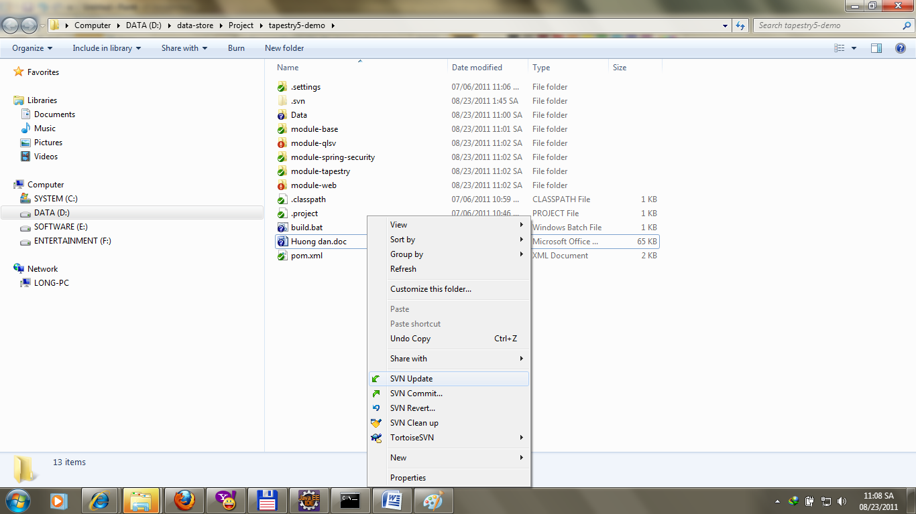

Build
Chay file build.bat de build. Khi build thanh cong se co hinh nhu ben duoi
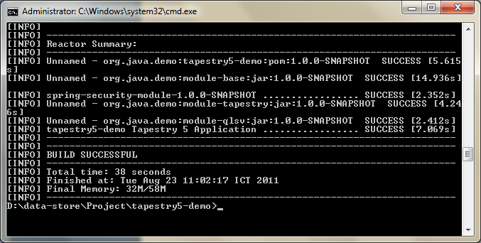

Deploy
Vao thu muc module-web\target, copy file t5demo.war (file nay se nop cho GV, cung voi nhung file trong thu muc Data) vao thu muc webapps cua Tomcat, VD: E:\Tomcat\apache-tomcat-6.0.20\webapps\
Cau truc cua thu muc Tomcat:
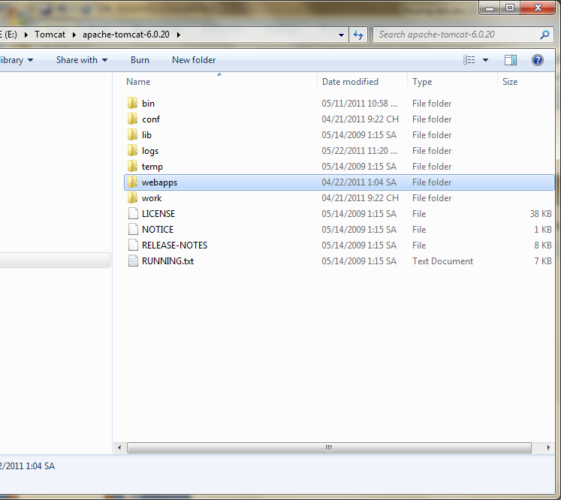

Chay CSDL
Chay file DB\start-db.bat de chay CSDL.
Muon xem du lieu trong CSDL thi chay file file DB\start-tool.bat (hinh ben duoi)
- Nhap cau truy van, roi Click « Execute SQL » de xem ket qua

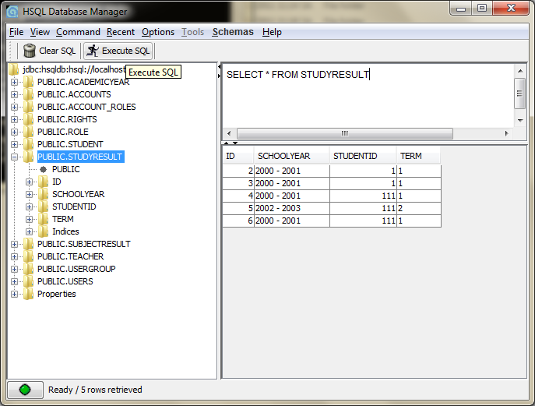

Chay Tomcat
Chay file bin\startup.bat trong thu muc Tomcat de khoi dong Tomcat

Truy cap ung dung
http://localhost:8080/qlsv

Dang nhap (login)
User: admin01
Pass: 123
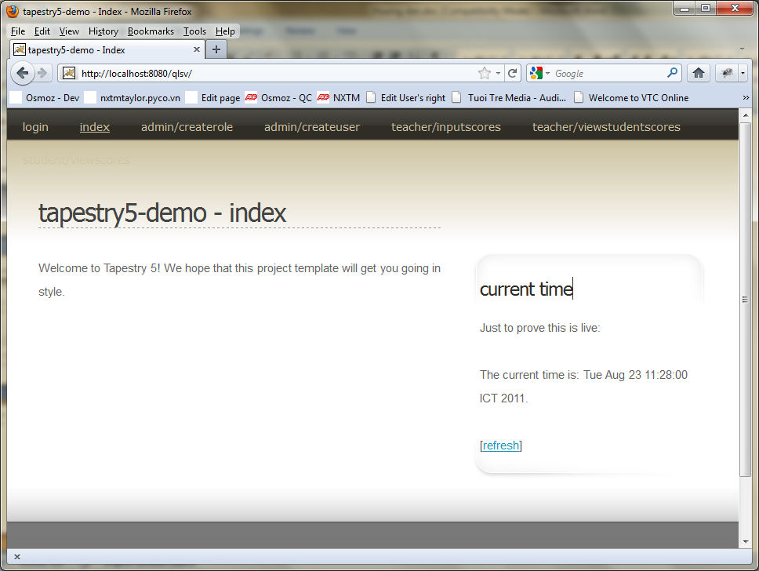

Cac User da duoc tao san
Vao trang:
http://localhost:8080/qlsv/admin/createuser
de tao them User va xem danh sach User co san
Chu y: Password cua cac User dc tao san deu la: 123

GV nhap diem
http://localhost:8080/qlsv/teacher/inputscores

SV xem diem
http://localhost:8080/qlsv/student/viewscores

GV xem diem
http://localhost:8080/qlsv/teacher/viewstudentscores

Nop bai
Nop file tapestry5-demo\module-web\target\t5demo.war va nguyen thu muc Data.
Nho huong dan GV cach cai dat vas su dung

